**MIGRATION OF DATA FROM ONE STORAGE ACCOUNT TO ANOTHER.**

Establish a secure SSH connection to the jumphost "Irchaosfp01.bankofamerica.com."

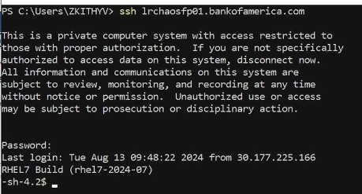

Run a bash shell with root privileges within a controlled environment managed by the PowerBroker system.

Enter the id,password and you’ll get a security code on authenticator.

# pbrun <group> <user=shell>

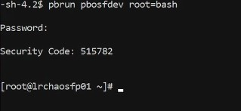

Navigate to /hosting/azure_cli/venv/bin where you’d find the activate script which sets up the environment variables and paths necessary to use the packages installed within the virtual environment. Run the script and configure the system to use a proxy server for HTTPS traffic.

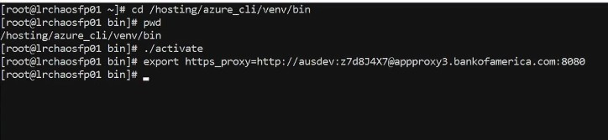

Establish an Azure CLI session using a service principal for authentication, allowing the user to interact with Azure resources using the provided credentials.

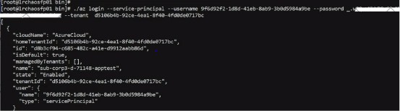

Specify the Azure subscription to be used for subsequent operations.Verify the details of the selected subscription by running ‘account show’ command.

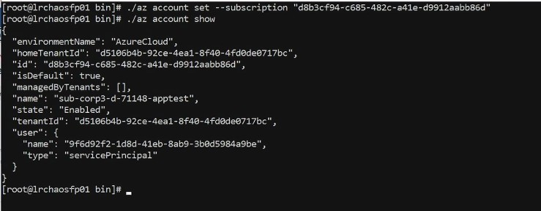

This Azure CLI command is used to list the blobs within a specific container in an Azure Storage account.

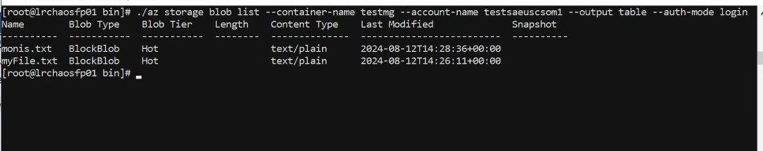

This Azure CLI command is used to upload a local file to an Azure Storage Blob container.

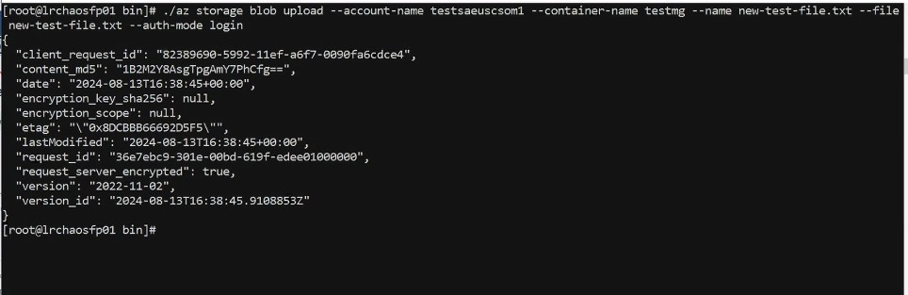

This Azure CLI command is used to list the blobs within a specific container in an Azure Storage account.The output shows a list of blobs within the specified container.

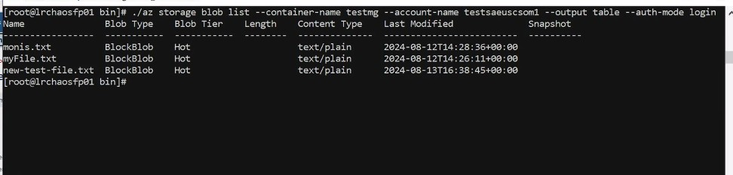

Script-

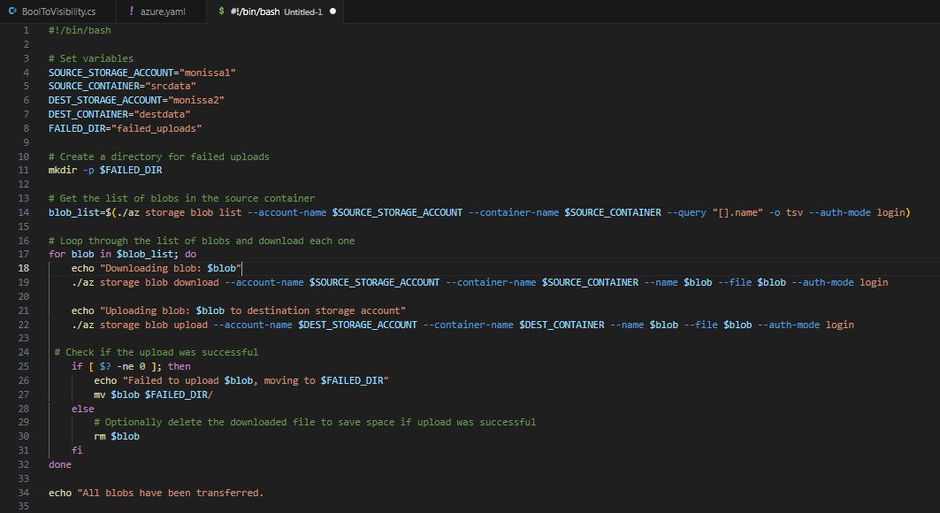

This Bash script transfers blobs from one Azure Storage container to another.

1. **Sets up:** Defines storage account names, container names, and a directory for failed uploads.
2. **Gets blob list:** Retrieves a list of blobs from the source container.

# Loops through blobs:

* + Downloads each blob to the local machine.
  + Uploads the downloaded blob to the destination container.
  + If upload fails, moves the blob to the failed uploads directory.
  + If upload succeeds, optionally deletes the downloaded file.

1. **Completes:** Indicates all blobs have been transferred.